**D.C. SPEED CONTROL**

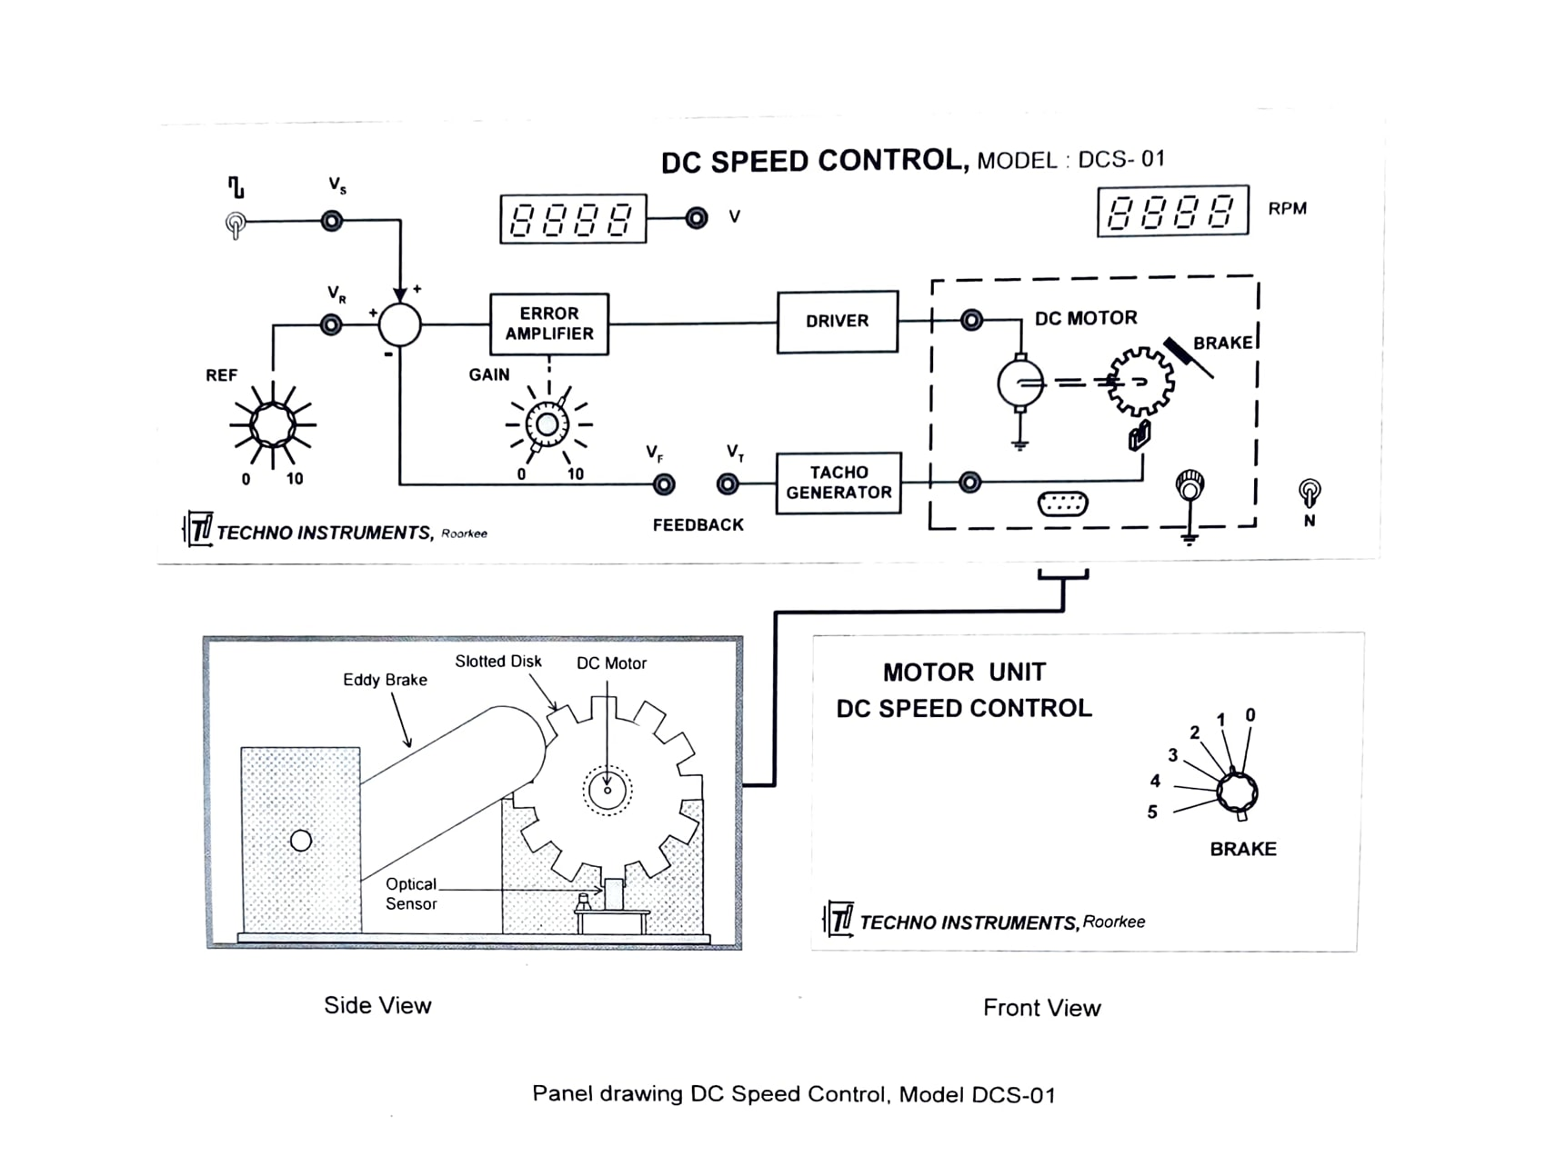

OBJECT

To study the performance characteristics of a D.C. motor speed control system.

EQUIPMENT DESCRIPTION

Speed control is a very common requirement in many industrial applications such as rolling mills, spinning mills, paper factories etc. The present unit is a low power D.C. motor speed control system designed as a laboratory experiment. The various components and subsystems have been carefully integrated, and the experiments are designed to illustrate the important performance characteristics in a simple way. Figure 1 shows a schematic of the system, Different blocks and parts of which are described below

(a) D.C. Motor: The 12 volt permanent magnet D.C. motor used in the system has the following specifications:

Rated voltage: 12 volt D.C.

Rated current: 200 mA at no load, 290 mA at full load

Torque: 50 gm-cm

Maximum speed: 3000 rpm

A slotted aluminum disk is mounted on the motor shaft which generates signals for speed measurement. Also, an adjustable eddy current brake is provided to enable the study of the effects of external disturbance on the system performance.

(b) Speed measurement: The slotted disk attached to the motor shaft generates 12 pulses for every revolution of the shaft through optical interruptions. After passing through signal conditioning and frequency scaling circuits, these pulses are then fed to a built-in frequency counter to display the shaft speed directly in rpm.

(c) Tachogenerator: A D.C. signal proportional to the shaft speed is obtained from an electronic tachogenerator - a frequency to voltage converter circuit. The signal is brought to a suitable level by signal conditioning to yield a tacho constant of about 0.5 V/1000 rpm.

(d) Error Detector and Forward Gain: The speed signal obtained from the tachogenerator is compared with the reference (corresponding to a set speed) to obtain an error signal. The error is amplified by a calibrated variable gain amplifier (0-100) and then fed to the driver circuit.

(e) Driver Circuit The driver circuit is designed to deliver the necessary power to operate the motor. It is a unity gain power amplifier and has all the necessary protection circuits ( Power and Signal Sources: A number of IC regulated supplies feed the electronic circuits. reference potentiometer, DVM, speed displays and the motor. Also, a square wave oscillator of 1 Hz (approx.) is included for time constant studies.

(g) DVM: A 19.99 Volt full-scale-deflection DVM mounted on the panel is available for the measurement of various signals. One terminal of the DVM is internally connected to ground.

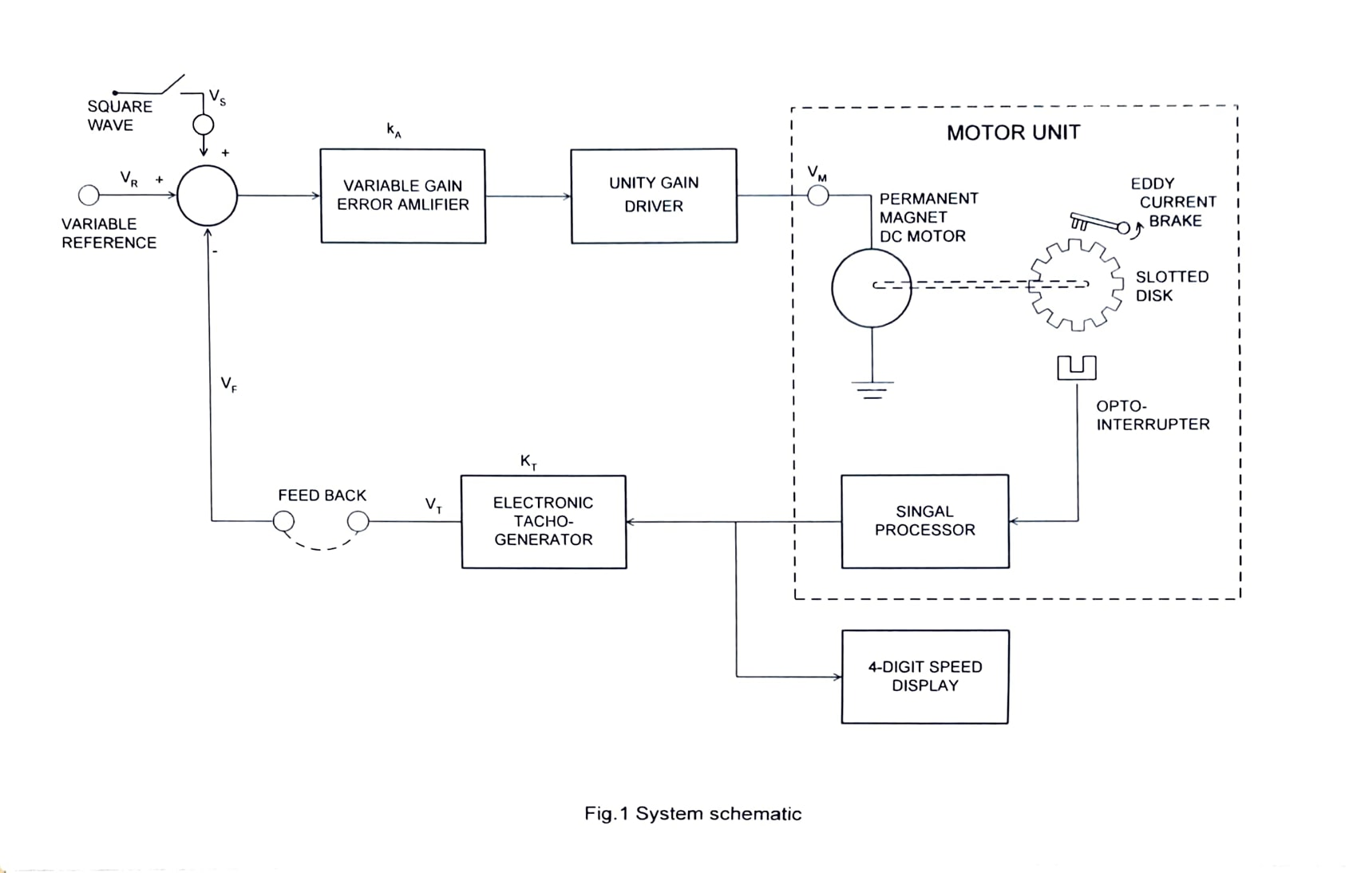

BACKGROUND SUMMARY

A basic block diagram of the D.C. motor speed control system is shown in Fig. 2. In order to evaluate the system performance, it is necessary to compute the overall transfer function in terms of the transfer functions of the different blocks. To start with, the transfer function of an armature controlled D.C. motor of Fig. 3 may be derived as [1. page nos. 30-321]

$\frac{θ\left(s\right)}{V\left(s\right)}=\frac{K_{M}}{s\left(sT+1\right)}$

Where $K_{M} is$ motor gain constant, and T is the mechanical time constant. Note that a permanent magnet D.C. motor should behave similar to a shunt motor with constant field excitation. Considering motor speed $ω rad/\sec{ \left(=\frac{dθ}{dt}\right)}$ as the output variable, the forward path transfer function may be written as.

$G\left(s\right)=\frac{ω\left(s\right)}{V_{E}\left(s\right)}=K_{A}.\frac{K_{M}}{sT+1}$…………………………………………………….….... (1)

Where, $K_{A} is$ is the gain of amplifier. Again, the tachogenerator transfer function (or gain) may be written as,

$H\left(s\right)=\frac{V_{T}\left(s\right)}{ω\left(s\right)}=K_{T}$

This yields the closed loop transfer function of the complete system as

$\frac{ω\left(s\right)}{V_{R}\left(s\right)}=\frac{K_{A}K_{M}}{sT+K_{A}K_{M}K_{T}+1}=\frac{\frac{K_{A}K_{M}}{K_{A}K_{M}K_{T}+1}}{s\left[\frac{T}{K_{A}K_{M}K_{T}+1}\right]+1}$………………………………………………. (2)

In Eq. 2, the transfer function of the closed loop system is seen to be a first order type-0 function. Its transient and steady state response to step input may be easily studied as described below.

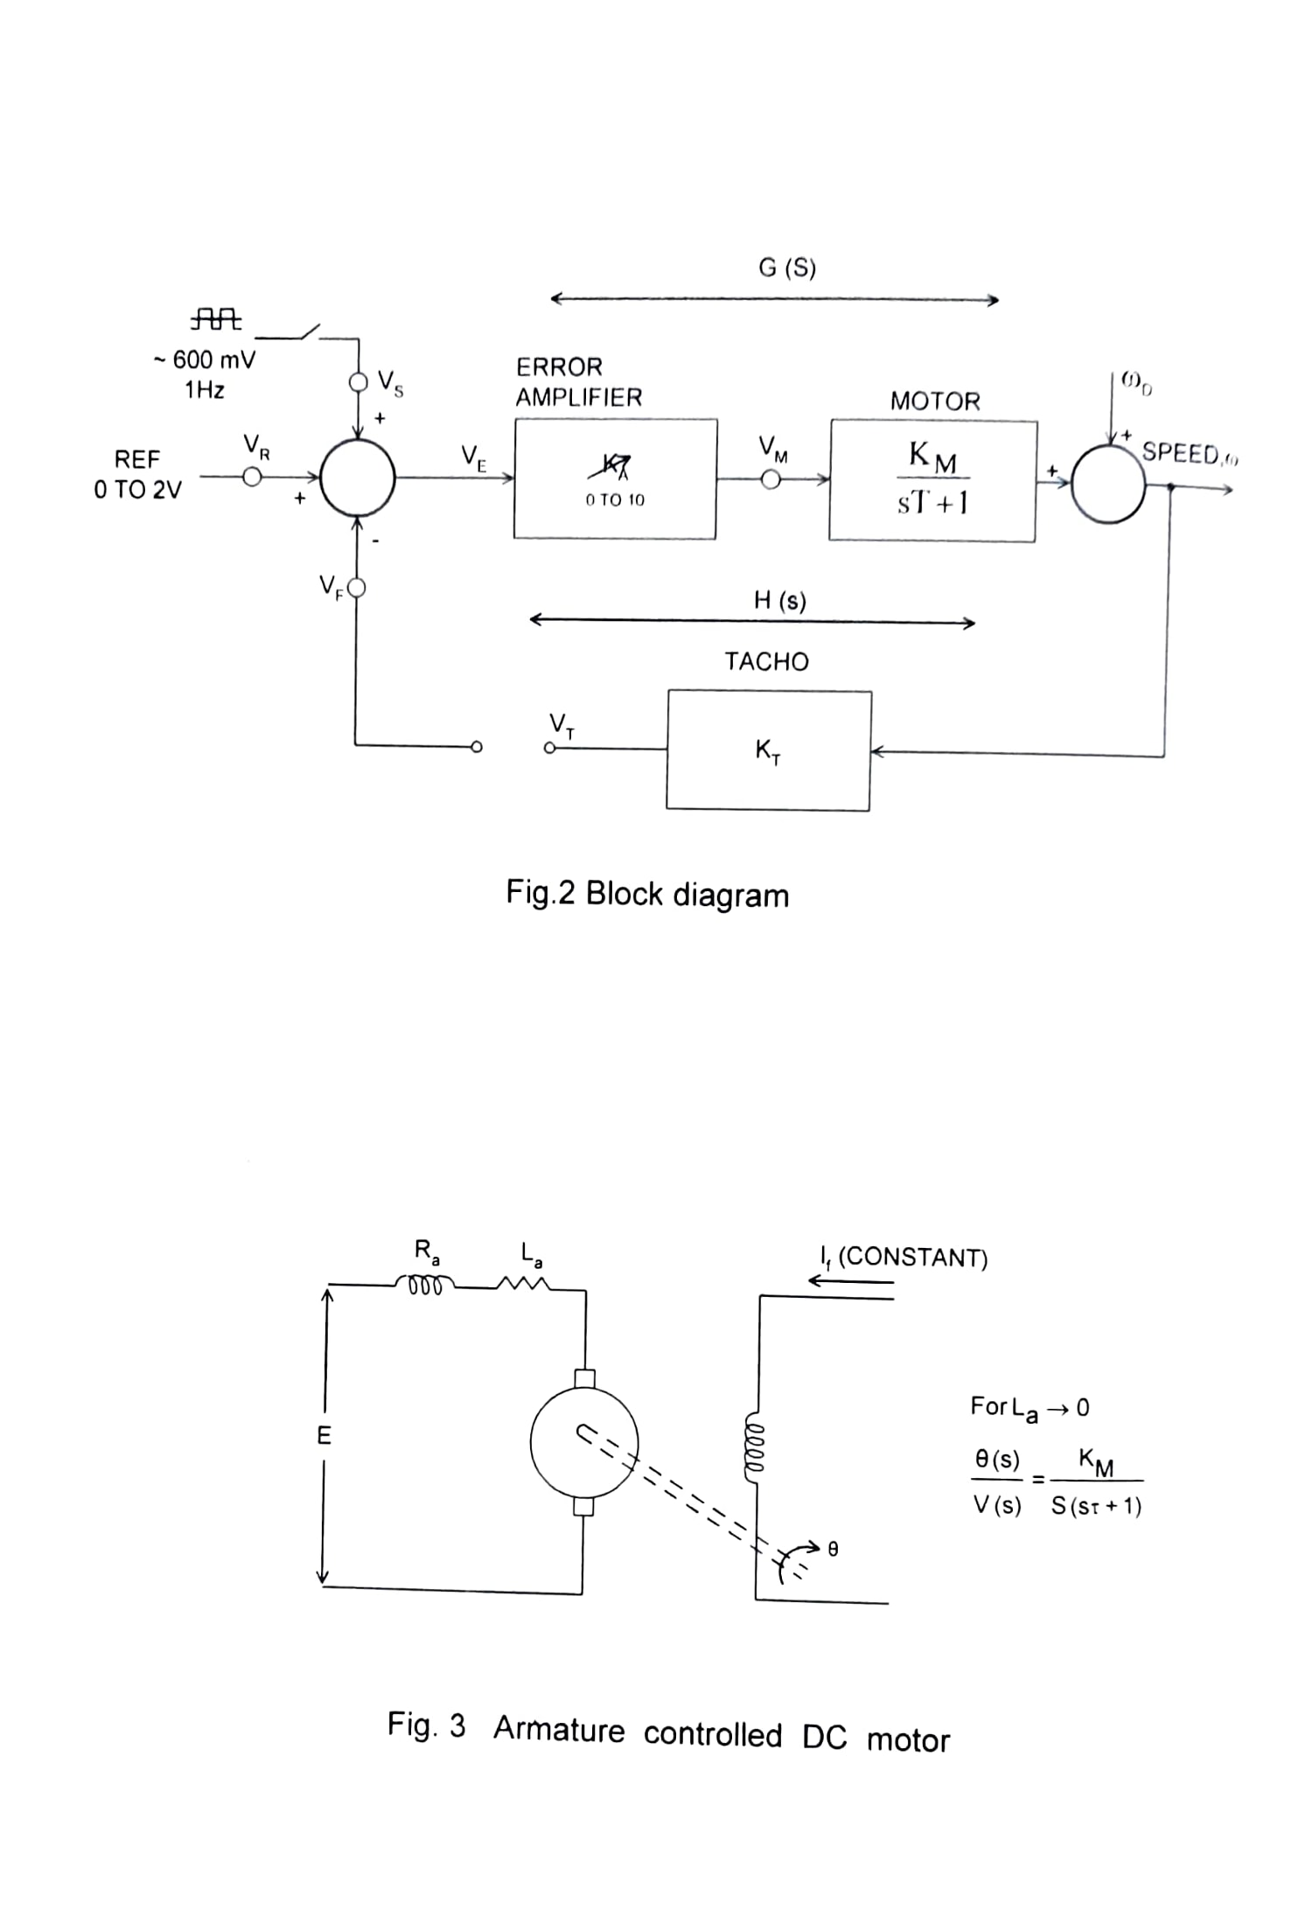

**Steady** **State** **Error**

Defining 'positional error coefficient, $K_{p} is$ as,

$$K_{P}=\lim_{s→0}{G\left(s\right).H\left(s\right)=K_{A}.K_{M}.K_{T},}$$

The steady state error $e_{ss }$ to step Input $R u(t)$, is given by,

$\lim_{s→∞}{(V_{R}-V_{T})}=\lim_{s→∞}{(V_{R}-}V_{F})=e_{ss}=\frac{R}{1+K_{P}}=\frac{R}{1+K_{A}K_{M}K_{T}}$…………………………… (3)

The steady state error may be determined from a measurement of $V_{R}$ and $V_{F}$ and

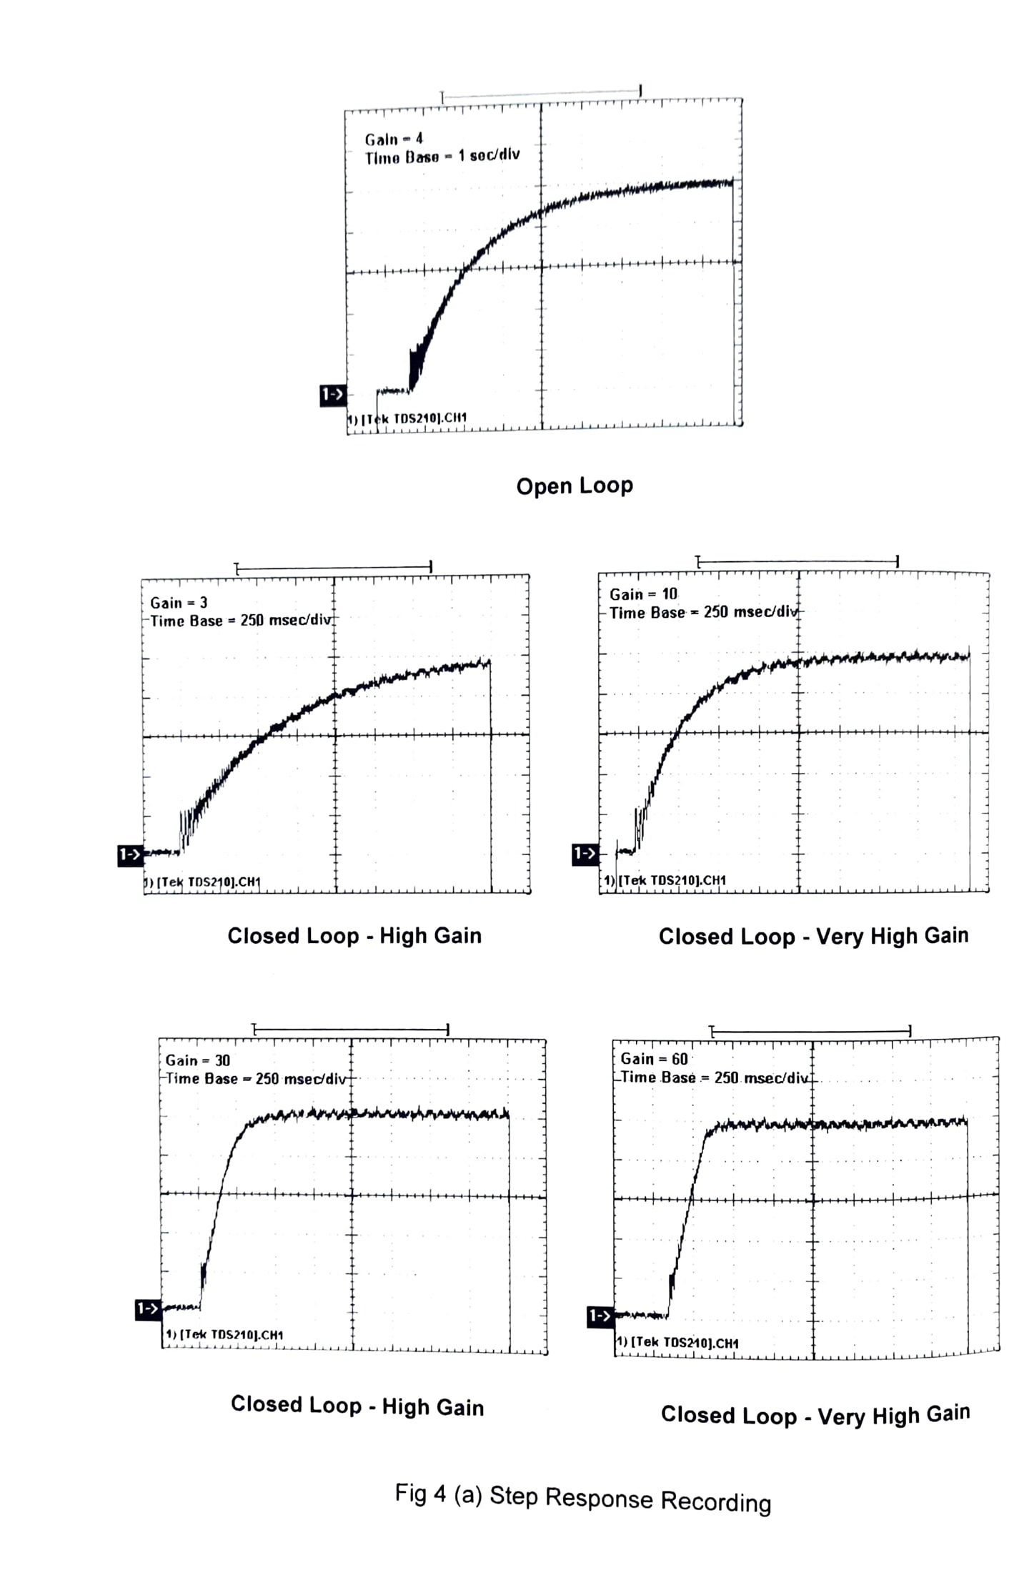The steady state error is expected to decrease as $K_{A} is$ is increased.

**Transient Response**

For a step input $V_{R}\left(s\right)=\frac{R}{s},$ Eq.2 yields

$$ω\left(s\right)=\frac{R}{s}.\frac{\left(\frac{K_{A}K_{M}}{T}\right)}{s+\left(K_{A}K_{M}K_{T}+1\right)/T}$$

Taking inverse Laplace transform

Where effective time constant $T_{eff} is$ may be defined as.

$$T_{eff}=\frac{T}{K_{A}K_{M}K_{T}+1}$$

The transient response has an exponential character similar to a capacitor charging through a resistor. Further, the effective time constant $T_{eff}$ decreases with increasing $K_{A}$ making the motor response faster.

The effective time constant may be determined from a recording of the step response using either a pen recorder or a storage CRO. The step response for various values of $K_{A}$ obtained through a storage oscilloscope, Tektronics, Model: TDS-210 is shown in Fig. 4 (a). It may further be observed that for large gains $(≥60)$ the speed of response becomes constant due to saturation of amplifier and/or motor. The initial portion of the response is therefore a straight line. Time constant may also be computed using an ordinary CRO as explained next.

Consider a general first order, type-0 transfer function of the form

$\frac{C\left(s\right)}{R\left(s\right)}=\frac{K}{sτ+1}$

Which may represent both open loop and closed loop speed control systems defined by $Eqs. \left(1\right)and (2)$. Its response to a step input, $Ru(t)$ may be seen to be $c\left(t\right)=R.K.(1-\exp\left(-\frac{t}{τ}\right)$

For a square wave of p-p value of R as input, referring to Fig. 4 (b) it is easy to see that

$τ=\frac{1}{2f}.\frac{1}{\ln\left(1-\frac{C\left(p-p\right)}{R\left(p-p\right)}.\frac{1}{K}\right)}$……………………………………….. (6)

Where f is the frequency of the square wave. The above equation suggests a method for computing the motor time constant T.

In the present electromechanical system, however, it is the shaft speed $ω$ which will go through a triangular wave type of variation in response to a square wave excitation, i.e. $C=ω(p-p)$. Since we are measuring the shaft speed using tachogenerator, $ω(p-p)$, given by $V_{T}(p-p)/K_{T}$, and $V_{M}(P-P)$, the motor input, the time constant may be found from the equation.

$T=\frac{1}{2f}.\frac{1}{\ln\left[1-\frac{V_{T}\left(P-P\right)}{V_{M}\left(P-P\right)}\right]}.\frac{1}{K_{M}K_{T}}, for open loop system$……………………………7(a)

$Where V_{M}\left(p-p\right)=K_{A}-V_{S}(P-P)$

And

$T=\frac{1}{2f}.\frac{1}{\left[1-\frac{V_{T}\left(P-P\right)}{V_{M}\left(P-P\right)}.\frac{1}{K_{M}K_{T}}\right] } , for close loop system$…………...7(b)

Where K includes only $K_{M}K_{T}$ product from Eq. (1).

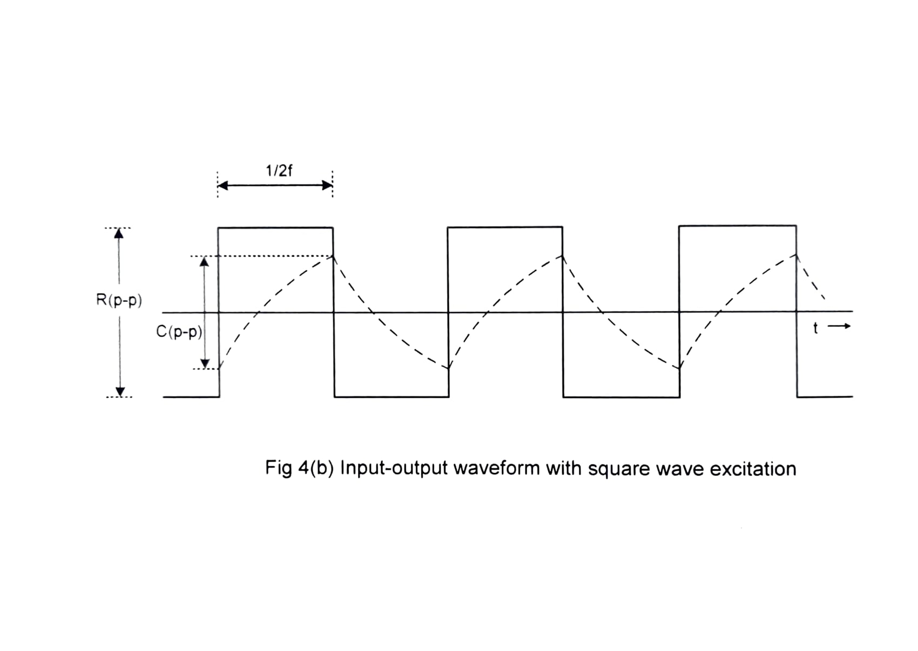

**Disturbance Rejection**

One of the important features of a feedback control system is its ability to reduce the effect of external disturbances. From Fig. 2, the disturbance transfer function for $V_{R}=0$, may be written as

$\frac{ω\left(s\right)}{ω_{D}\left(s\right)}=\frac{1}{1+G\left(s\right)H\left(s\right)}=\frac{sT+1}{sT+1+K_{A}K_{M}K_{T}}$

For a unit step disturbance, $ω_{D}\left(s\right)=Ω_{D}/s,$ the steady state output speed is given by

$ω_{ss}=\frac{Ω_{D}}{K_{A}K_{M}K_{T}+1}$…………………………………………………………………………….. (8)

Thus, the steady state speed change caused by an external disturbance should reduce as the gain $K_{A}$ is increased. Also, the performance should be much superior to the open loop case, i.e. with feedback disconnected $(K_{T}=0)$

In the experimental unit, the external disturbance is created by an eddy current brake. The pole pieces of a permanent magnet are inserted to varying depths into the rotating aluminum disk. The eddy currents induced in the disk result in power loss and thereby load the motor.

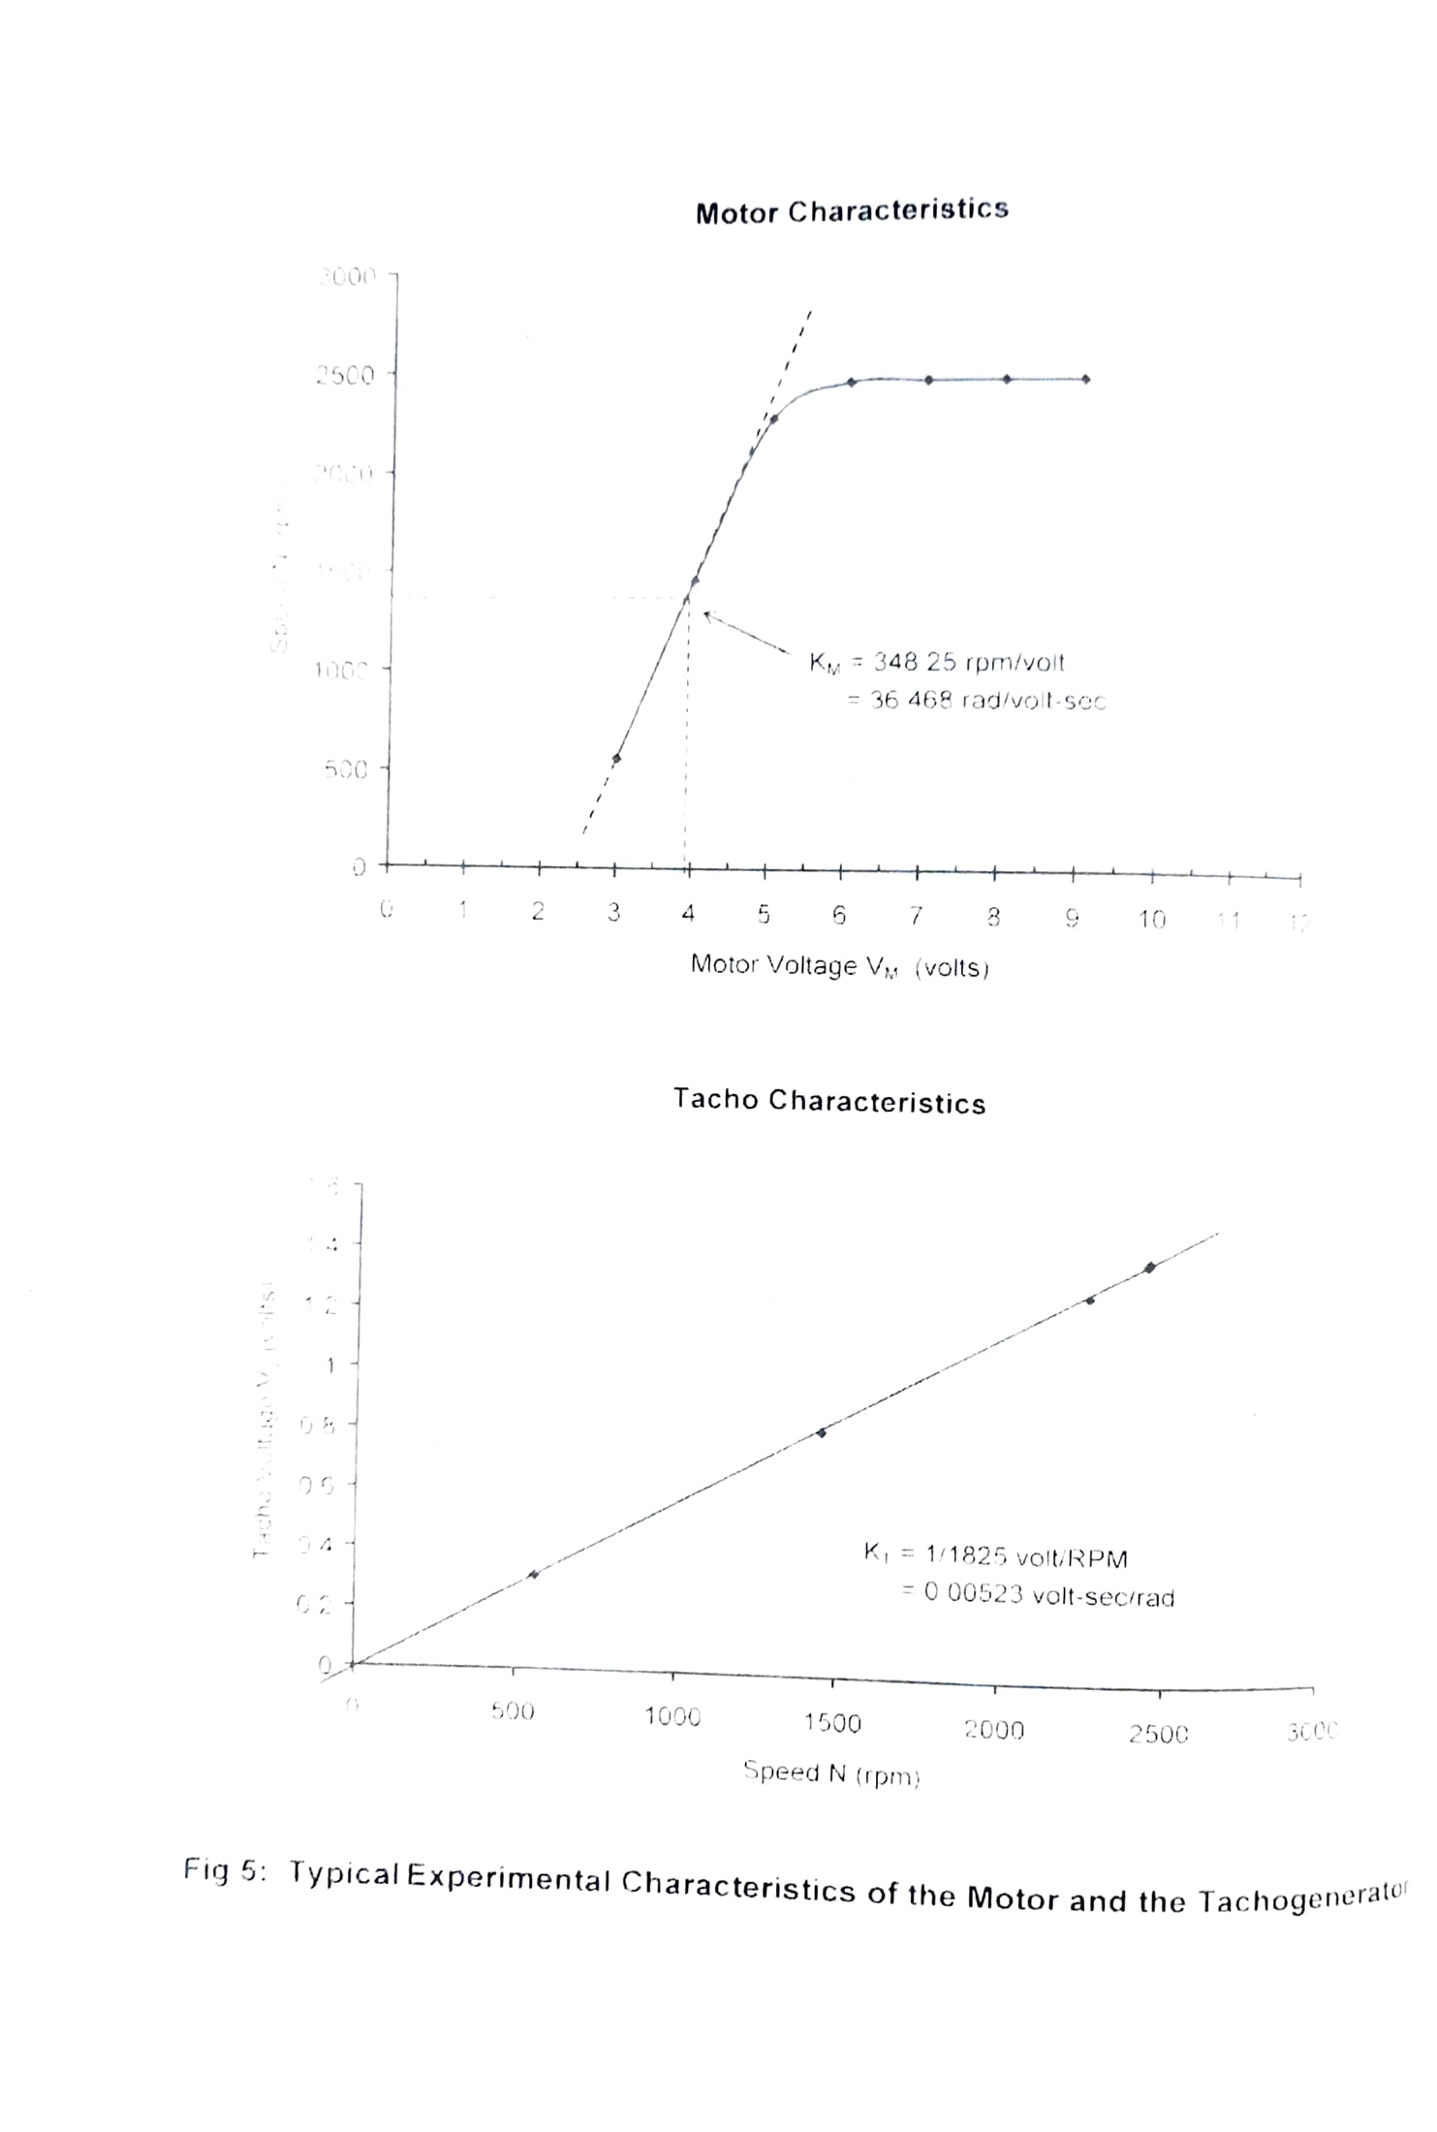

**4. EXPERIMENTAL WORK**

The experiments suggested in this section start with a study of the open loop system and its subsystems. This is followed by the performance evaluation of the closed loop system for various operating conditions like forward path gain and disturbance.

**4.1 Subsystem Performance**

Various subsystem blocks are shown in Fig. I and 2. The characteristics of motor tachogenerator and square wave source are determined first. The FEEDBACK terminals are left open during this experiment. **Note that $K_{A}$ may be varied from 0 to 100 using a 10- turn potentiometer. Thus one turn of the potentiometer corresponds to gain variation from 0 to 10.**

**Signal and reference**

Set $K_{A}$ =0. Connect DVM to measure the range of variation of reference voltage

VR.

Switch ON the square wave signal Vs and measure its amplitude and frequency using a calibrated CRO. The frequency of this signal is about 1Hz. which makes the CRO display very inconvenient for measurements. It is suggested that the amplitude may be measured with time-base switched OFF, and for frequency simply count the number of pulses (as seen on CRO screen), in say 60 seconds, using a watch.

**Motor and Tachogenerator**

Set $V_{R}=1$ Volt and $K_{A}=3$**.** The motor may be running at a low speed. Record speed N in rpm, and the Tachogenerator output $V_{T}$.

Repeat with $V_{R}=1$ and $K_{A}=4, 5,……..10$, and tabulate measured motor voltage $V_{M}\left(=V_{R}K_{A}\right),$ steady state motor speed N in rpm (or $ω_{ss}=N×2π/60$ in radians/sec.) and tachogenerator output $V_{T}$.

Plot N vs, $V_{M}$ and $V_{T}$ vs, N. Obtain $K_{M}$ and $K_{T}$ from the linear region of the curves (see Fig. 5).

Motor gain constant, $K_{M}=\frac{shaft speed in\frac{rad}{sec},ω_{ss}}{Motor voltage, V_{M}}$**and**

Tachogenerator gain, $K_{T}=\frac{V_{T}}{ω_{ss}}\frac{volt-sec}{rad}$

To calculate motor time constant, with square wave signal $V_{S}$ ON, set $V_{R}$ and $K_{A}$ so that the peak-to-peak variation of $V_{M}$ lies between 3-8V. This would ensure a reasonably linear operation of the motor. Use Eq. (7) to calculate the motor time constant T.

(Caution: The CRO must be kept in 'dc-input' mode for this measurement.)

Obtain the motor transfer function using $G\left(s\right)=\frac{K_{M}}{sT+1}$

**(c) Disturbance**

Set $K_{A}=5$ and adjust the reference $V_{R}$ to get a speed reading close to 1200 rpm. **The brake setting should be at 0 i.e. no braking.**

Record and tabulate the motor speed variation for different settings of the eddy current brake.

Calculate percentage decrease in speed at each setting of the brake, starting from no braking.

**Closed Loop Performance**

Performance of the closed loop system is evaluated in terms of steady state error and disturbance rejection as functions of forward gain. The FEEDBACK terminals are connected together for this experiment.

**Steady state error**

Set $V_{R}=1$ volt and $K_{A}$ =5. The motor may be running at a low speed. Measure and record speed N in rpm, tachogenerator voltage $V_{T}$, and the steady state error $e_{ss}(= V_{R}- V_{T})$**.**

Repeat above for $K_{A}$ = 5, 10, 15, 20.........100

Compare in each case the value of steady state error computed from Eq. (3) i.e. $e_{ss}=\frac{1}{1+ K_{A} K_{M} K_{T}}$

Comment on the results.

**Transient Performance**

Set $V_{R}=0.5$ Volt and $K_{A}$ =5. Switch ON the square wave signal and measure peak-to-peak amplitudes of $V_{S}$ and $V_{T}$. Use Eq. (7) to calculate system time constant $T_{eff} with R= V_{S}\left(P-P\right) and C= V_{T}(P-P)$. The value of K may be obtained from (2) as $K=\frac{K_{A}K_{M}}{K_{A}K_{M}K_{T}+1}$

(Note: Although the method suggested above is theoretically valid, in the experimental unit the results are likely to be erroneous. As the closed loop system encounters a step input, the motor is driven harder (increased input) so as to force it to respond faster. The current limitation and saturation in the amplifier does not permit this in a linear fashion. However for small values of K, say less than 5, the results are reasonable.)

**(c) Disturbance Rejection**

With $K_{A}$ =5, FEEDBACK terminals shorted and the brake setting at 0, adjust reference VR to get a speed close to 1200 rpm.

Record and tabulate the variation in speed for different settings of the eddy current brake. Calculate percentage decrease in speed at each setting of the brake.

Repeat above for $K_{A}$ =10, 50, 100.

Compare the percentage decrease in speed at various brake settings for open loop, closed loop with $K_{A}$ =5, and closed loop with $K_{A}$ =10. Comment on the results.

**5. RESULTS**

Typical results obtained on an experimental unit are given below for guidance. **Motor and Tachogenerator Characteristics**

|  |  |  |  |  |  |
| --- | --- | --- | --- | --- | --- |
| S. No. | $K_{A}$**Setting** | N rpm | $V_{T}$**Volt** | $V_{M}$**Volt** | Experimental $K_{A}= V_{M}/ V_{R}$ |
| 1  2  3  4  5  6  7 | 3  4  5  6  7  8  9 | 560  1453  2264  2440  2445  2445  2445 | 0.31  0.81  1.27  1.38  1.39  1.39  1.39 | 3.01  4.19  5.45  6.46  7.44  8.55  9.59 | 3.01  4.19  5.45  6.46  7.44  8.55  9.59 |

Graphs of $N vs V_{M}, and V_{T}vs N,$ are shown in Fig. 5. From the linear region, $K_{M}$ and $K_{T}$ are obtained as. $K_{M}$ =36.468, $K_{T}$ =0.00523, and $K_{M}K_{T}$ =0.19

Time constant was obtained as

$$T=\frac{1}{2f}.\frac{1}{\ln\left[1- \frac{V_{T}\left(P-P\right)}{V_{M}\left(P-P\right)}\frac{.1}{K_{M}K_{T}} \right]}=\frac{1}{2×0.82ln\left[1-\frac{0.04}{0.8}.\frac{1}{0.19}\right]}=1.997 sec.$$

Where f=0.82Hz, $V_{M}$ = 0.8V (p-p), $V_{T}$ =40mV (p-p) and the motor transfer function as

$$G\left(s\right)=\frac{K_{M}}{sT+1}=\frac{36.468}{1.997S+1}$$

Note that the motor speed-voltage characteristics is rather non-linear. This is because the motor fails to start at very low voltages and at higher voltages its speed saturates due to internal speed limiter.

**(b) Closed loop performance**

**Steady state error**

$V_{R}=1 Volt$

|  |  |  |  |  |  |
| --- | --- | --- | --- | --- | --- |
| S. No. | $$K_{A}$$ | N rpm | $$V_{T} Volt$$ | $$e_{ss}=( V_{R}- V_{T)}$$ Experimental | $$e_{ss}=\frac{1}{1+K_{A}K_{M}K_{T}}$$ Theoretical |
| 1  2  3  4  5  6  7  8 | 5  10  15  20  25  50  75  100 | 648  1083  1276  1377  1442  1581  1635  1656 | 0.37  0.62  0.73  0.79  0.82  0.90  0.93  0.94 | 0.63  0.38  0.27  0.21  0.18  0.10  0.07  0.06 | 0.516  0.348  0.262  0.210  0.175  0.096  0.066  0.0506 |

Observe that the numerical values of theoretical and experimentally obtained steady state error do not match, though the pattern of variation is same i.e. it decreases with increase in forward gain. The mismatch is due to the fact that the motor gain constant KM does not remain constant due to non-linearity of the motor.

**(ii) System time constant**

$$V_{R}=0.5V d.c.$$

$$f=0.82 Hz$$

$$K_{A}=5, V_{P}=480 mV\left(p-p\right), V_{T}=120mV(P-P)$$

From equation 7(b)

$K_{eff}=\frac{K_{A}K_{M}K_{T}}{1+K_{A}K_{M}K_{T}}=\frac{5×0.19}{1+5×0.19}=0.487,$**And**

$T_{eff}=\frac{1}{2×0.82} .\frac{1}{ln\left(1-\frac{1}{0.487}.\frac{120}{480}\right)}=846 msec$

**(iii) Disturbance rejection**

Speed=1200 rpm (approx.)

The table below shows the variation of speed under various conditions of feedback and thus illustrates the effectiveness of speed control system in rejecting disturbance.

|  |  |  |  |  |  |  |
| --- | --- | --- | --- | --- | --- | --- |
| Brake setting | 0 | 1 | 2 | 3 | 4 | 5 |
| Open loop speed, rpm | 1204 | 1200 | 1136 | 812 | 596 | 563 |
| Closed Loop $$K_{A}=5$$ | 1205 | 1203 | 1182 | 1023 | 910 | 886 |
| Closed Loop $$K_{A}=10$$ | 1208 | 1205 | 1189 | 1107 | 1010 | 991 |
| Closed Loop $$K_{A}=50$$ | 1186 | 1186 | 1183 | 1156 | 1134 | 1128 |
| Closed Loop $$K_{A}=100$$ | 1196 | 1195 | 1192 | 1178 | 1167 | 1164 |